

**Projet HTML : Les grands monuments historiques du monde**

*Réalisé par*: Lloyd Darryl NGUIDJOL OBIANG et MOUSSA DANTIA GALI

Notre projet portera sur la réalisation d’un site web sur les monuments historiques considérés comme des Merveilles du monde.

**1-Présentation du Template**

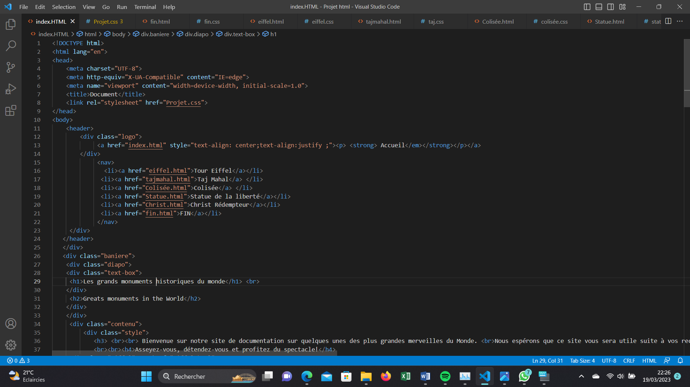

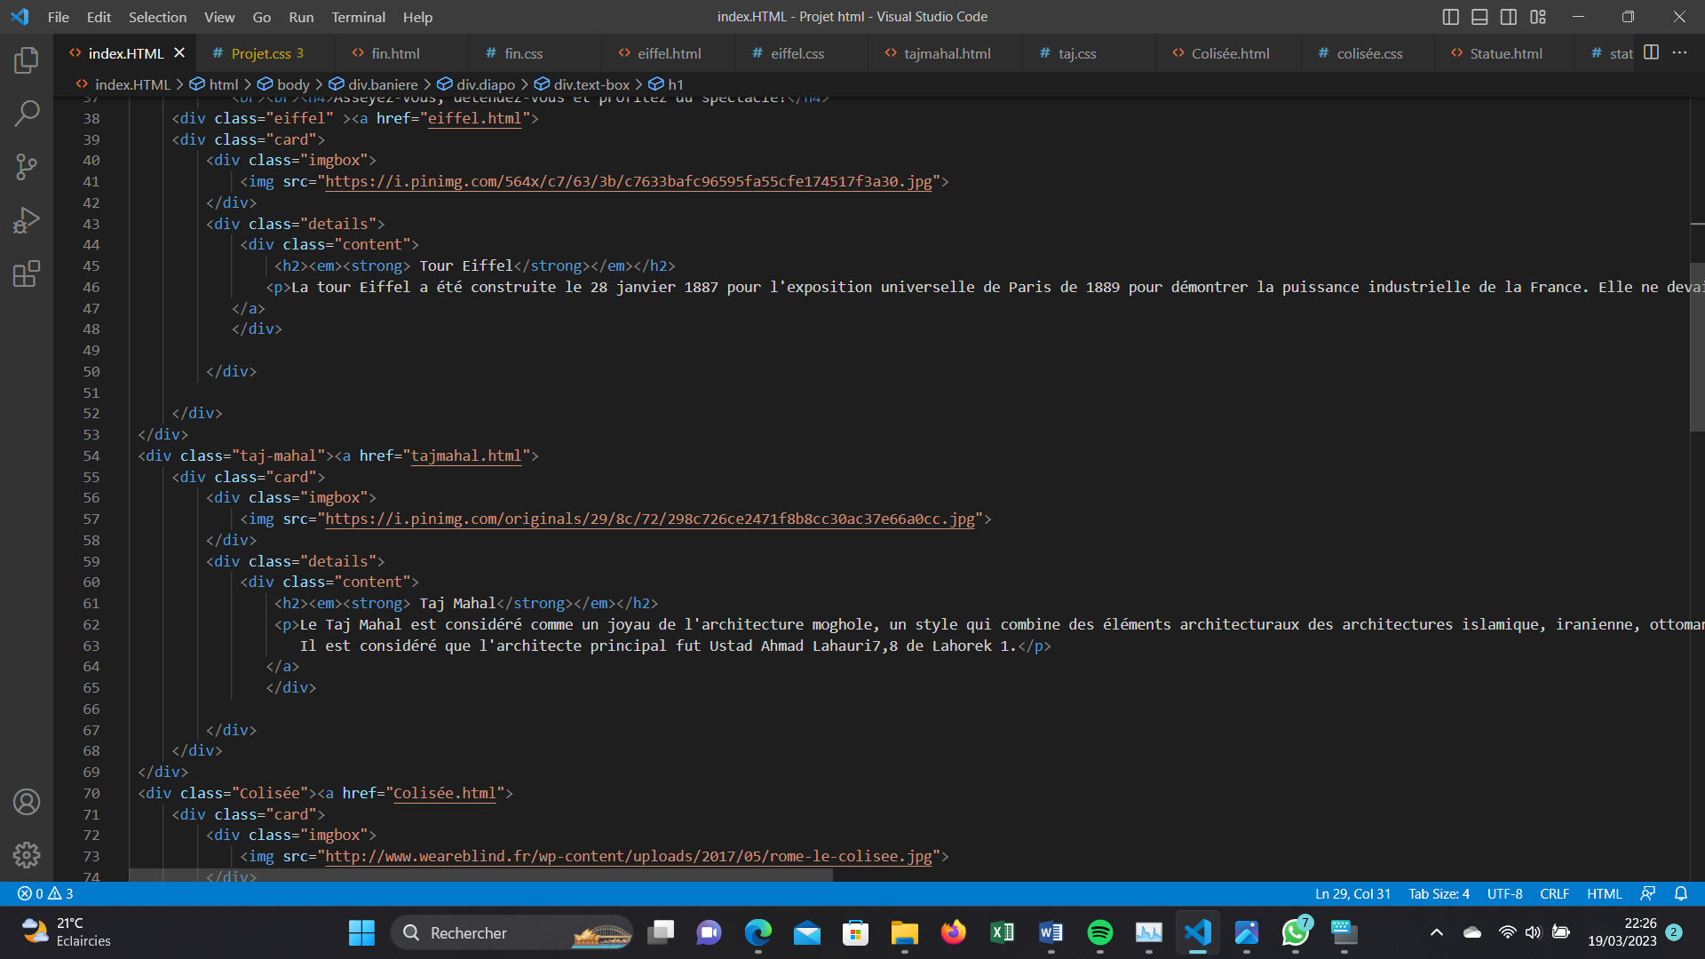

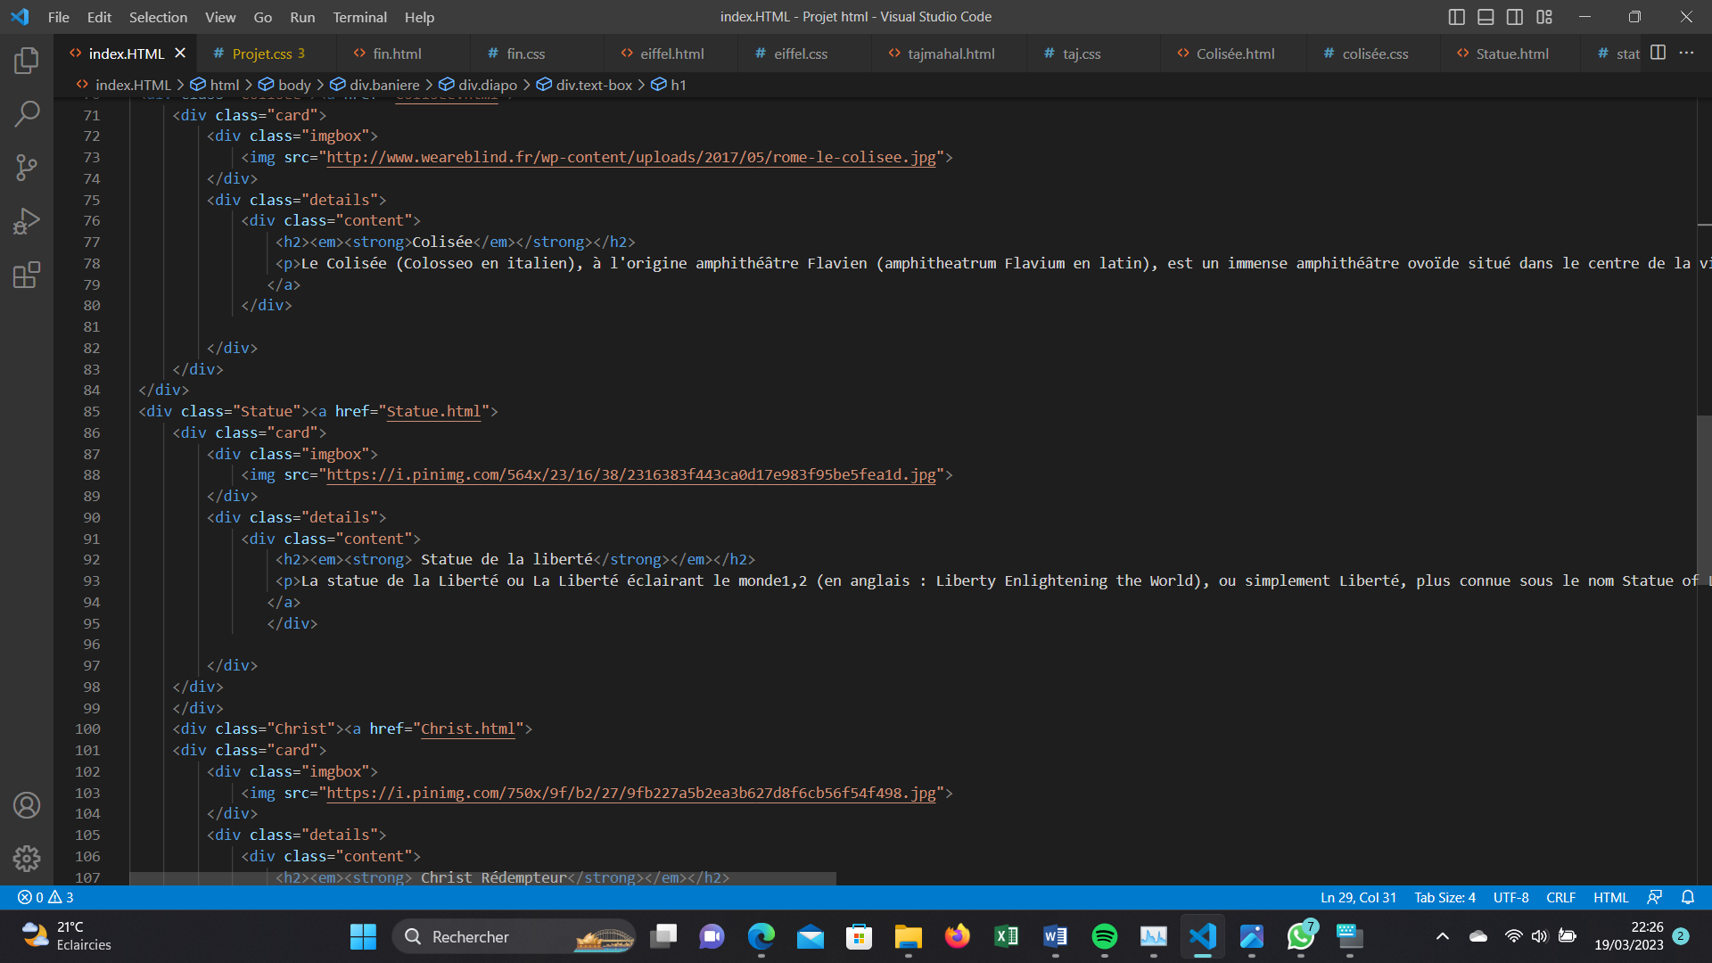

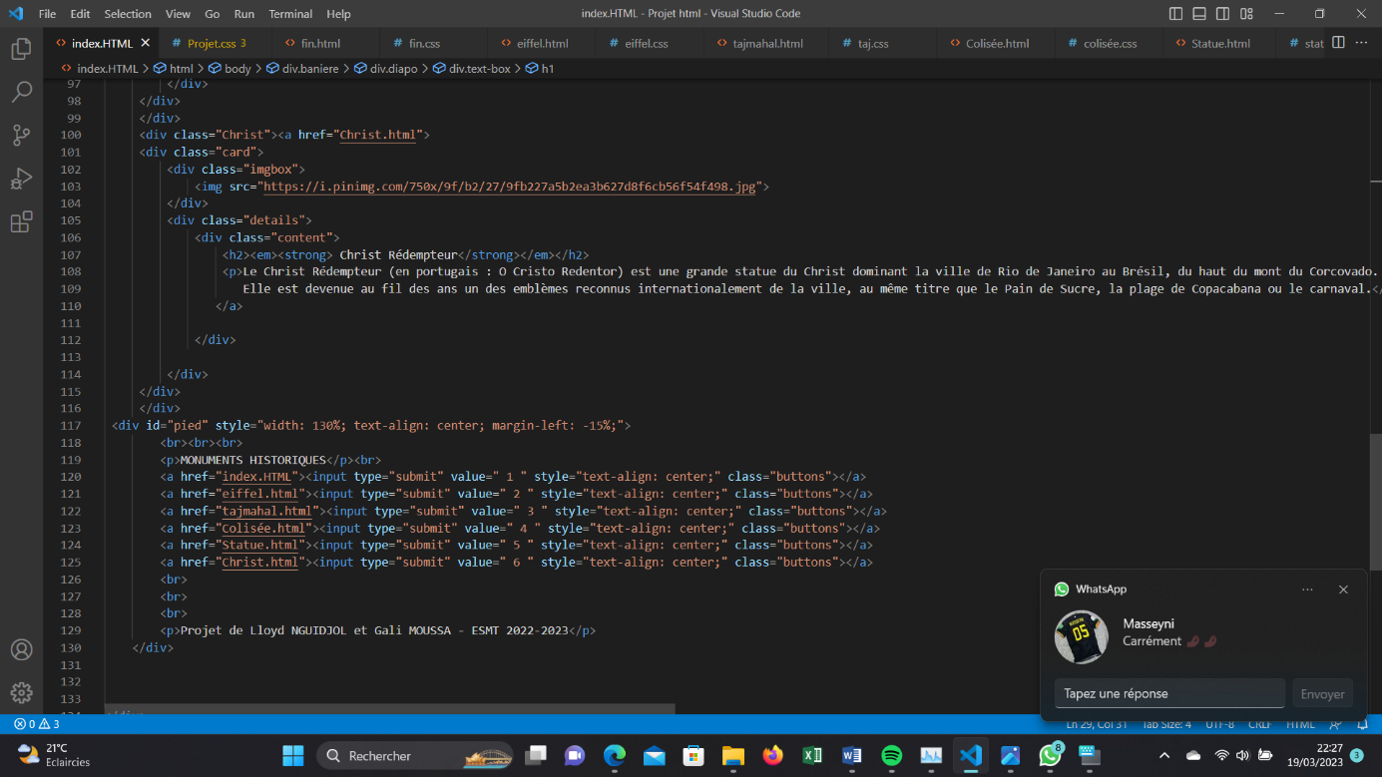

|  |  |
| --- | --- |
| ELEMENTS | STYLE ASSOCIE |
| body | background-color: bisque |
| header | height: 100px;  background-image: url(télécharger.jpg) |
| .logo | width: 30%;  float: left;  line-height: 100px; |

|  |  |
| --- | --- |
| .logo a | font-family: poppins;  color: #fff;  letter-spacing: 5px; |
| .logo a:hover | color: rgb(40, 8, 41) |
| nav | float: right;  line-height: 70px; |
| nav a | text-decoration: none;  font-family: Arial, Helvetica, sans-serif;  font-size: 20px;  margin: 0 0px;  color: rgb(247, 247, 247);  font-weight: 700; |
| li a:hover | color: rgb(40, 8, 41); |
| nav li | display: inline-block;  color: white;  padding-left: 50px;  padding-right: 20px; |
| .baniere | width: 100%;  height: 600px;  top: 100px;  -webkit-background-size: cover;  background-size: cover;  background-position: center center; |
| .baniere h1 | padding-top: 8%;  font-size: 80px;  font-family: poppins;  text-transform: uppercase;  color: white;  text-align: center; |
| .baniere h2 | color: rgb(255, 255, 255);  text-align: center;  font-family:'Gill Sans', 'Gill Sans MT', Calibri, 'Trebuchet MS', sans-serif;  font-size: 50px; |
| h3 | color: #fff;  text-align: center;  font-family:'Courier New', Courier, monospace;  font-size: 30px; |
| h4 | color: pink;  text-align: center;  font-family:'Trebuchet MS', 'Lucida Sans Unicode', 'Lucida Grande', 'Lucida Sans', Arial, sans-serif;  font-size: 35px; |
| .eiffel | margin-left: 50%; |
| .text-box h1 | position: relative;  left: 6%;  top: 20%;  bottom: 30px;  color: transparent;  -webkit-text-stroke: 1px #fff;  background: url(back.png);  -webkit-background-clip: text;  animation:back 20s linear infinite;  line-height: 70px; |
| .card | position: relative;  width: 300px;  height: 400px;  background: #fff;  transform-style: preserve-3d;  transform: perspective(1000px);  box-shadow: 10px 20px 40px rgba(0, 0, 0, 0.25);  transition: 1s;  ; |
| .card hover | transform: translateX(50%); |
| .card .imgbox | position: relative;  width: 100%;  height: 100%;  z-index: 1;  transform-origin: left;  transform-style: preserve-3d;  transition: 1s; |
| .card :hover .imgbox | transform: rotateY(-180deg); |
| .card .imgbox img | position: absolute;  top: 0;  left: 0;  width: 100%;  height: 100%;  object-fit: cover;  transform-style: preserve-3d;  transition: 1s; |

|  |  |
| --- | --- |
|  |  |

|  |  |
| --- | --- |
| .card .details | position: absolute;  top: 0;  left: 0;  width: 100%;  height: 100%;  padding: 20px;  display: flex;  justify-content: center;  align-items: center; |
| .card .details .content | display: flex;  justify-content: center;  align-items: center;  flex-direction: column; |
| .card .details .content h2 | text-align:left;  font-weight: 700;  line-height: 1em; |
| .card .details .content p | color: black;  font-size: small; |
| .card | position: relative;  width: 300px;  height: 400px;  background: #fff;  transform-style: preserve-3d;  transform: perspective(1000px);  box-shadow: 10px 20px 40px rgba(0, 0, 0, 0.25);  transition: 1s; |
| .card:hover | transform: translateX(50%); |
| .card .imgbox | position: relative;  width: 100%;  height: 100%;  z-index: 1;  transform-origin: left;  transform-style: preserve-3d;  transition: 1s; |
| .card:hover .imgbox | transform: rotateY(-180deg); |

|  |  |
| --- | --- |
| .card .imgbox img | position: absolute;  top: 0;  left: 0;  width: 100%;  height: 100%;  object-fit: cover;  transform-style: preserve-3d;  transition: 1s; |
| .card .details | position: absolute;  top: 0;  left: 0;  width: 100%;  height: 100%;  padding: 20px;  display: flex;  justify-content: center;  align-items: center; |
| .card .details .content h2 | text-align:left;  font-weight: 700;  line-height: 1em; |
| .card .details .content p | color: black;  font-size: small; |
| .card | position: relative;  width: 300px;  height: 400px;  background: #fff;  transform-style: preserve-3d;  transform: perspective(1000px);  box-shadow: 10px 20px 40px rgba(0, 0, 0, 0.25);  transition: 1s; |
| .card:hover | transform: translateX(50%); |
| .card .imgbox | position: relative;  width: 100%;  height: 100%;  z-index: 1;  transform-origin: left;  transform-style: preserve-3d;  transition: 1s; |
| .card:hover .imgbox | transform: rotateY(-180deg); |
| .card .imgbox img | position: absolute;  top: 0;  left: 0;  width: 100%;  height: 100%;  object-fit: cover;  transform-style: preserve-3d;  transition: 1s; |

|  |  |
| --- | --- |
| .card .details | position: relative;  top: 0;  left: 0;  width: 100%;  height: 100%;  padding: 20px;  display: flex;  justify-content: center;  align-items: center; |
| .card .details .content | display: flex;  justify-content: center;  align-items: center;  flex-direction: column; |
| .card .details .content h2 | text-align:left;  font-weight: 700;  line-height: 1em;  } |
| .card .details .content p | color: black;  font-size: small; |
| .card | position: relative;  width: 300px;  height: 400px;  background: #fff;  transform-style: preserve-3d;  transform: perspective(1000px);  box-shadow: 10px 20px 40px rgba(0, 0, 0, 0.25);  transition: 1s; |
| .card:hover | transform: translateX(50%); |
| .card .imgbox | position: relative;  width: 100%;  height: 100%;  z-index: 1;  transform-origin: left;  transform-style: preserve-3d;  transition: 1s; |
| .card:hover .imgbox | transform: rotateY(-180deg) |
| .card .imgbox img | position: absolute;  top: 0;  left: 0;  width: 100%;  height: 100%;  object-fit: cover;  transform-style: preserve-3d;  transition: 1s; |
| .card .details | position: relative;  top: 0;  left: 0;  width: 100%;  height: 100%;  padding: 20px;  display: flex;  justify-content: center;  align-items: center; |
| .card .details .content | display: flex;  justify-content: center;  align-items: center;  flex-direction: column; |
| .card .details .content h2 | text-align:left;  font-weight: 700;  line-height: 1em; |
| .card .details .content p | color: black;  font-size: small; |
| .card | position: relative;  width: 300px;  height: 400px;  background: #fff;  transform-style: preserve-3d;  transform: perspective(1000px);  box-shadow: 10px 20px 40px rgba(0, 0, 0, 0.25);  transition: 1s; |
| .card .imgbox | position: relative;  width: 100%;  height: 100%;  z-index: 1;  transform-origin: left;  transform-style: preserve-3d;  transition: 1s; |
| .card:hover .imgbox | transform: rotateY(-180deg) |
| .card .imgbox img | position: absolute;  top: 0;  left: 0;  width: 100%;  height: 100%;  object-fit: cover;  transform-style: preserve-3d;  transition: 1s; |
| .card .details | position: absolute;  top: 0;  left: 0;  width: 100%;  height: 100%;  padding: 20px;  display: flex;  justify-content: center;  align-items: center; |
| .card .details .content | display: flex;  justify-content: center;  align-items: center;  flex-direction: column; |
| .card .details .content h2 | text-align:left;  font-weight: 700;  line-height: 1em; |
| .card .details .content p | color: black;  font-size: small; |
| .Colisée{ | margin-left: 50%; |
| .card | position: relative;  width: 300px;  height: 400px;  background: #fff;  transform-style: preserve-3d;  transform: perspective(1000px);  box-shadow: 10px 20px 40px rgba(0, 0, 0, 0.25);  transition: 1s;  } |
| .card:hover | transform: translateX(50%) |
| .card .imgbox | position: relative;  width: 100%;  height: 100%;  z-index: 1;  transform-origin: left;  transform-style: preserve-3d;  transition: 1s; |
| .card:hover .imgbox | transform: rotateY(-180deg);  } |
| .card .imgbox img | position: absolute;  top: 0;  left: 0;  width: 100%;  height: 100%;  object-fit: cover;  transform-style: preserve-3d;  transition: 1s; |
| .card .details | position: absolute;  top: 0;  left: 0;  width: 100%;  height: 100%;  padding: 20px;  display: flex;  justify-content: center;  align-items: center; |
| .card .details .content | display: flex;  justify-content: center;  align-items: center;  flex-direction: column; |
| .card .details .content h2 | text-align:left;  font-weight: 700;  line-height: 1em; |
| .card .details .content p | color: black;  font-size: small; |
| .Christ | margin-left: 50%; |
| .card | position: relative;  width: 300px;  height: 400px;  background: #fff;  transform-style: preserve-3d;  transform: perspective(1000px);  box-shadow: 10px 20px 40px rgba(0, 0, 0, 0.25);  transition: 1s;  top: 100px; |
| .card:hover | transform: translateX(50%); |
| .card .imgbox | position: relative;  width: 100%;  height: 100%;  z-index: 1;  transform-origin: left;  transform-style: preserve-3d;  transition: 1s; |
| .card:hover .imgbox | transform: rotateY(-180deg); |
| .card .imgbox img | position: absolute;  top: 0;  left: 0;  width: 100%;  height: 100%;  object-fit: cover;  transform-style: preserve-3d;  transition: 1s; |
| .card .details | position: absolute;  top: 0;  left: 0;  width: 100%;  height: 100%;  padding: 20px;  display: flex;  justify-content: center;  align-items: center;  } |
| .card .details .content | display: flex;  justify-content: center;  align-items: center;  flex-direction: column |
| .card .details .content h2 | text-align:left;  font-weight: 700;  line-height: 1em; |
| .card .details .content p | color: black;  font-size: small |
| .style | width: 1170px;  margin: 0 auto; |
| @keyframes back | 100%{  background-position: 2000px 0;  } |
| /*diapo*/  .diapo | /*margin: 0 auto;*/  flex: 1 0 auto;  height: 100%;  /*border: 3px solid rgb (255, 255, 255);*/  background-size: cover;  -webkit-animation-name: diapo;  -webkit-animation-duration: 10s;  -webkit-animation-timing-function: linear;  -webkit-animation-iteration-count: infinite;  -webkit-animation-direction: normal;  -moz-animation-name: diapo;  -moz-animation-duration: 10s;  -moz-animation-timing-function: linear;  -moz-animation-iteration-count: infinite;  -moz-animation-direction: normal;  animation-name: diapo; animation-duration: 10s;  animation-timing-function: linear;  animation-iteration-count: infinite;  animation-direction: normal; |
| @-webkit-keyframes diapo | 0% {background-image: url(eiffel-tower-paris-beautiful-view-1s-1280x720.jpg) ;background-size: cover}  33% {background-image: url(photo-1587135941948-670b381f08ce.JPG) ;background-size: cover}  66% {background-image: url(photo-1593854586136-2edae149504c.JPG) ;background-size: cover}  100%{background-image: url(photo-1605130284535-11dd9eedc58a.JPG) ;background-size: cover} |
| @-moz-keyframes diapo | 0% {background-image: url(eiffel-tower-paris-beautiful-view-1s-1280x720.jpg) ;background-size: cover}  33% {background-image: url(photo-1587135941948-670b381f08ce.JPG) ;background-size: cover}  66% {background-image: url(photo-1593854586136-2edae149504c.JPG) ;background-size: cover}  100%{background-image: url(photo-1605130284535-11dd9eedc58a.JPG) ;background-size: cover} |
| #pied | margin-top: 16%;  padding-bottom: 20px;  padding-right: 0;  background-color: black;  text-align: center;  border-bottom-left-radius: 20px;  border-bottom-right-radius: 20px; |
| #pied p | margin-top: 0px;  padding: 0px 50px;  font-size: 20px;  line-height: 1.6;  font-weight: 300;  letter-spacing: 0.059em;  color: whitesmoke;  font-family:system-ui, -apple-system, BlinkMacSystemFont, 'Segoe UI', Roboto, Oxygen, Ubuntu, Cantarell, 'Open Sans', 'Helvetica Neue', sans-serif; |
| .buttons | border-color: aqua;  background-color: rgb(240, 183, 113);  cursor: pointer;  border-radius: 20px;  font-size: 15px;  font-weight: 150px;  letter-spacing: 1px; |
| .contenu | width: 100%;  position: relative;  top: 600px;  background-image: url(city_buildings_architecture_215565_2560x1440.jpg);  height: 2200px;  background-position: center center |
| .contenu h2 | font-family: poppins;  letter-spacing: 4px;  padding-top: 30px;  font-size: 40px;  margin: 0;  color: black; |
| .contenu p | padding: 2% 0px;  font-family: poppins;  line-height: 30px;  font-size: 30px; |

**3-lien du site web :**

**4-*CAPTURES D’éCRAN DES PAGES***

**Capture d’écran de la page n°1 (Accueil)**

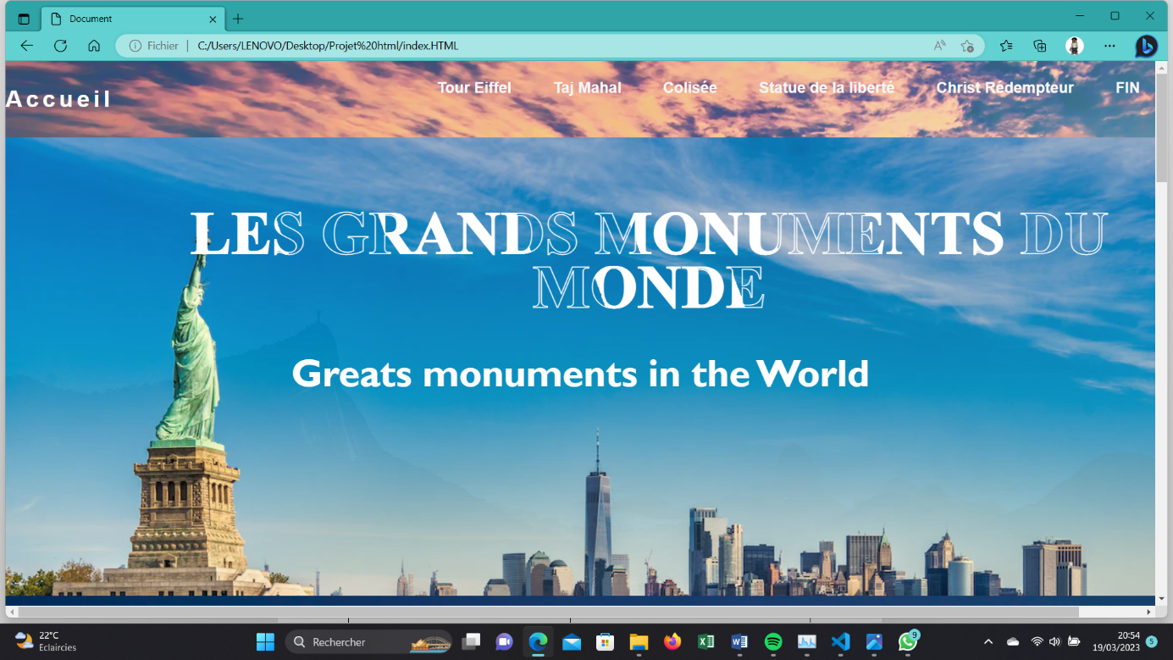

**Capture d’écran de la page n°2 (Tour Eiffel)**

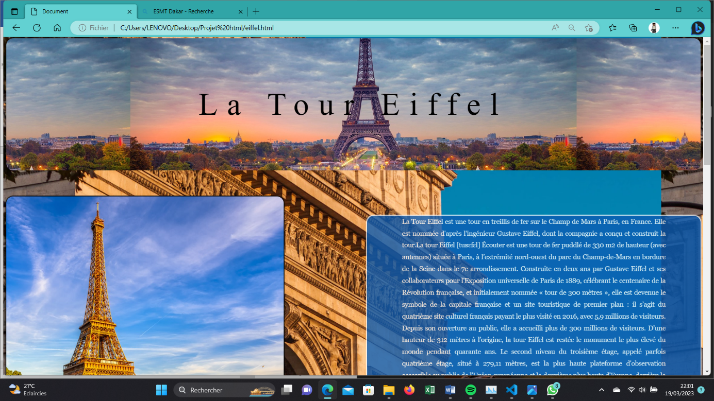

**Capture d’écran de la page n°3 (Taj Mahal)**

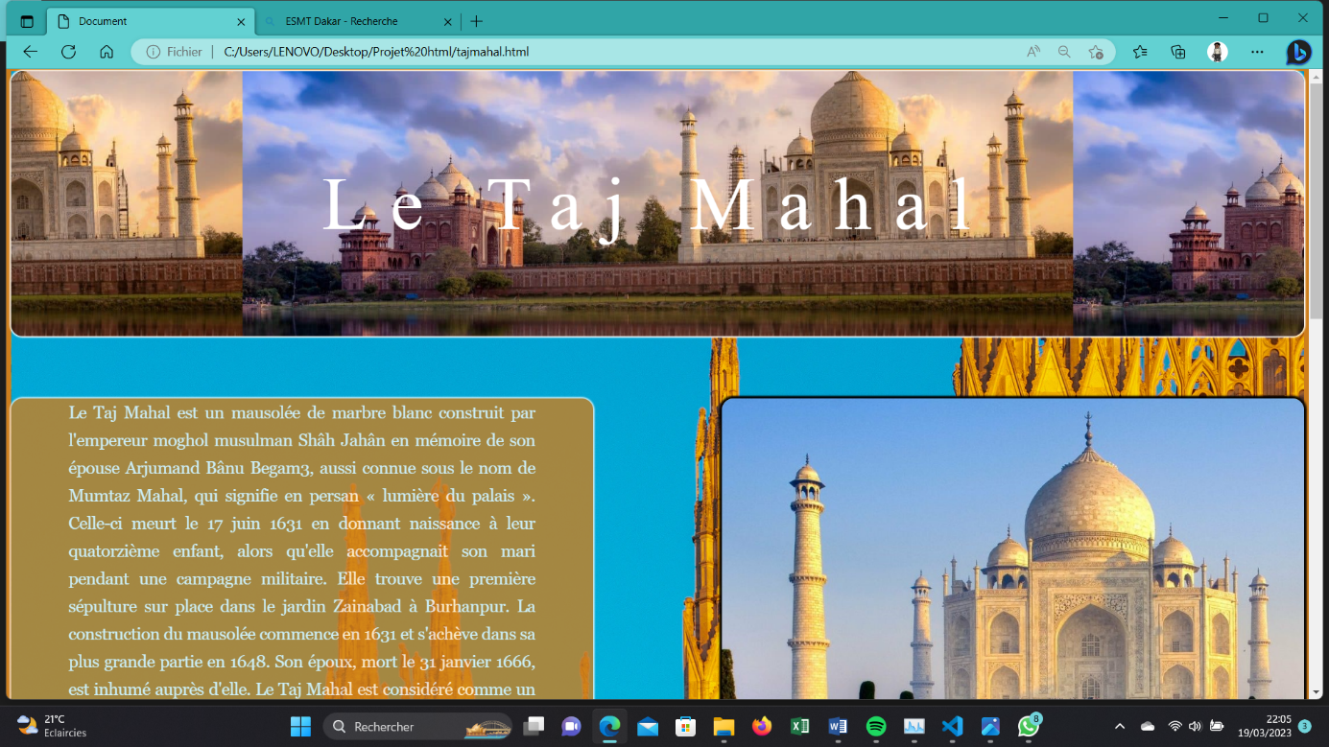

**Capture d’écran de la page n°4 (Colisée)**

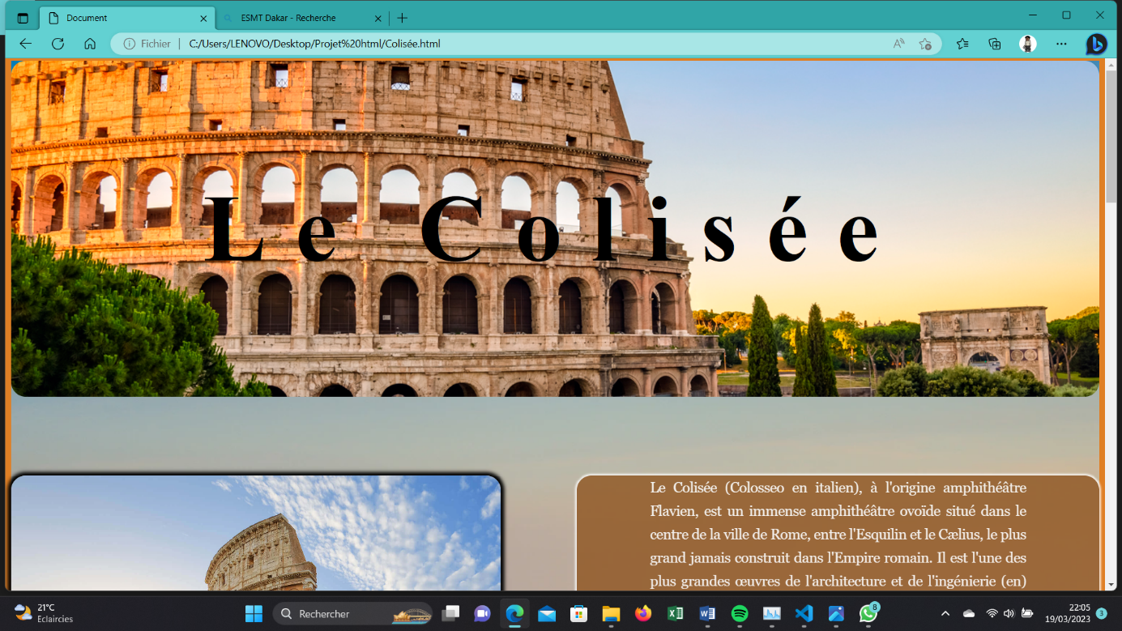

**Capture d’écran de la page n°5 (Statue de la liberté)** 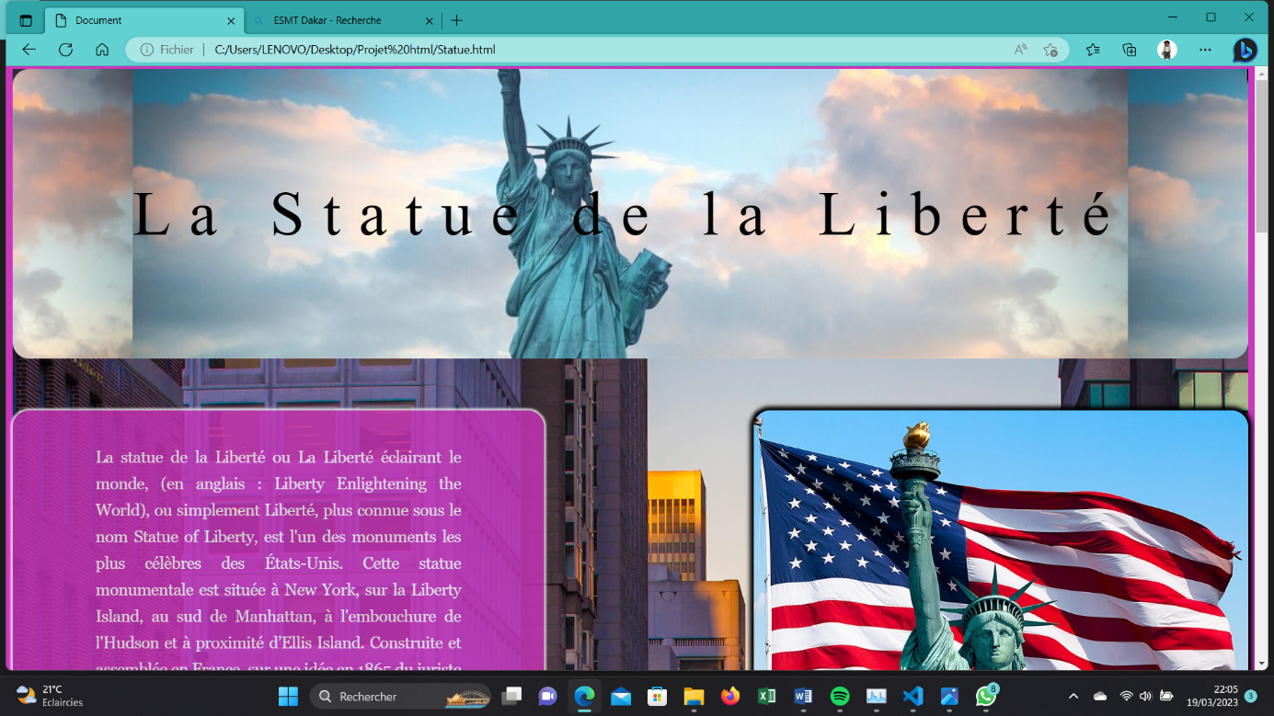

**Capture d’écran de la page n°6 (Christ Rédempteur)**

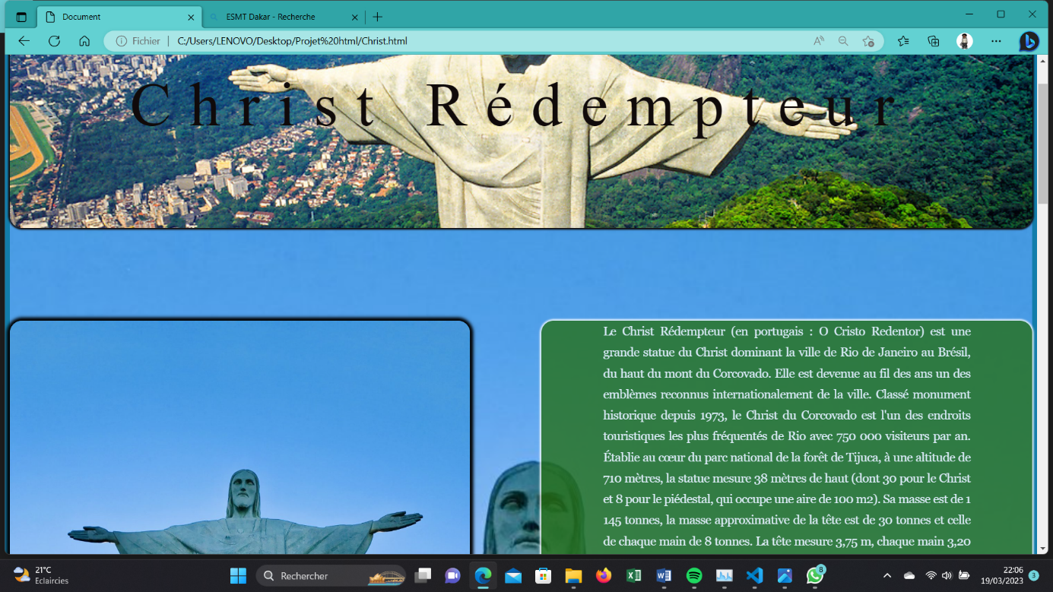

**Capture d’écran de la page n°7 (FIN)**

